|  |  |  |  |  |  |
| --- | --- | --- | --- | --- | --- |
| Date | 24-Nov-22 | | | Tester Name | Mohammad Yusuf |
| Environment | Penfax - Test | | | Login used |  |
| Operating System | Windows | Version: | Update: | | |
| Software Used | Select Software | Version: | Update: | | |
| Select Software | Version: | Update: | | |
| Release version |  | | | | |
| Title |  | | | | |
| Test Type | Regression | | | | |
| Test Scenario |  | | | | |
|  |  | | | | |
| Expected Results |  | | | | |
| Pass/Fail | Select | | | JIRA# | N/A |

Describe your steps with screenshots:

Pre-condition: Login into the application.

Generally, the executor is created when there is Date of Death

Person Profile -> Click on Edit. Add date of Death

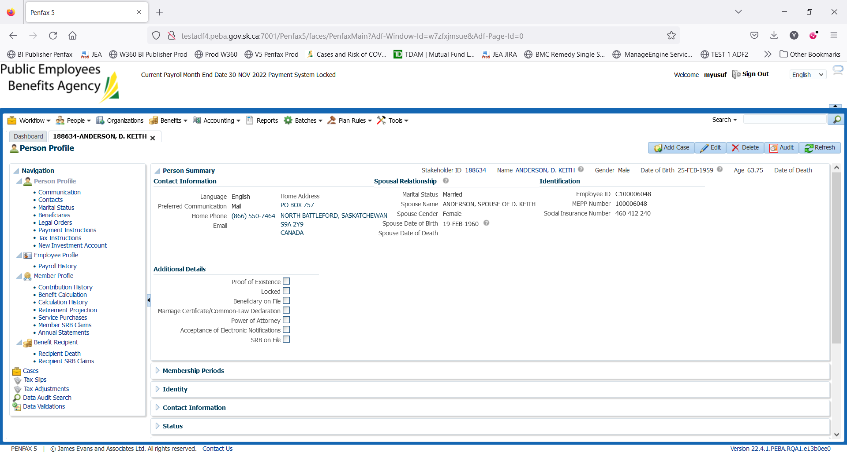

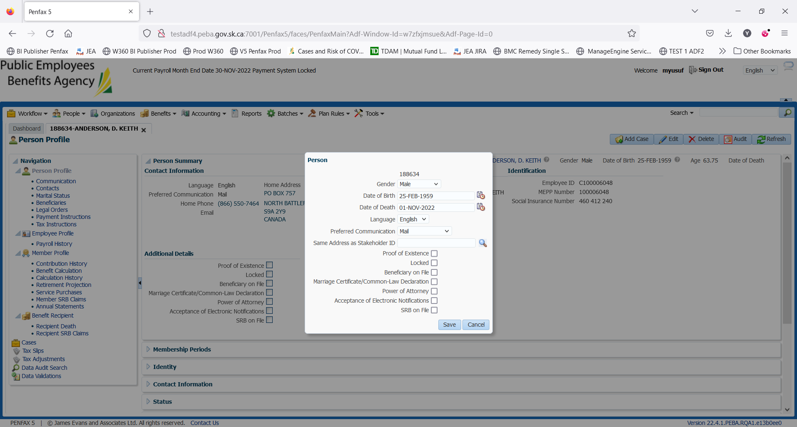

Select a pensioned person. Navigate to Person Profile -> Legal Orders

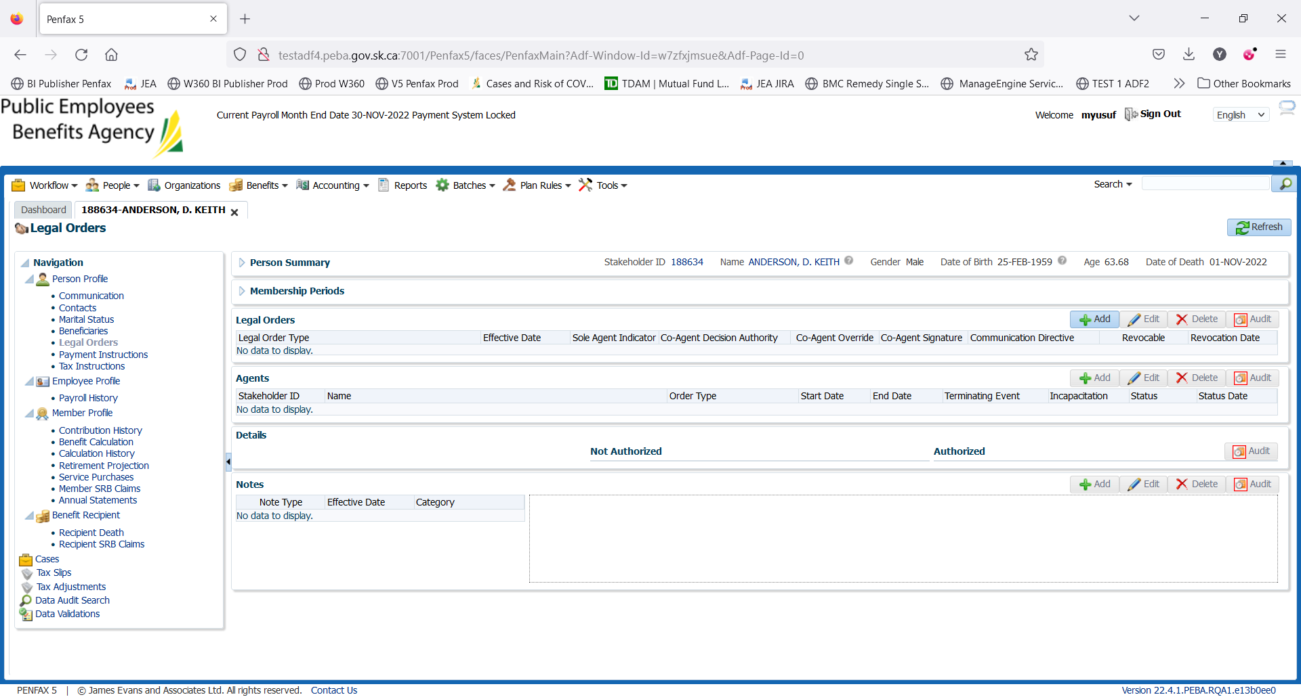

Click on add button under Legal Orders. Select the Legal Order Type -> Executor

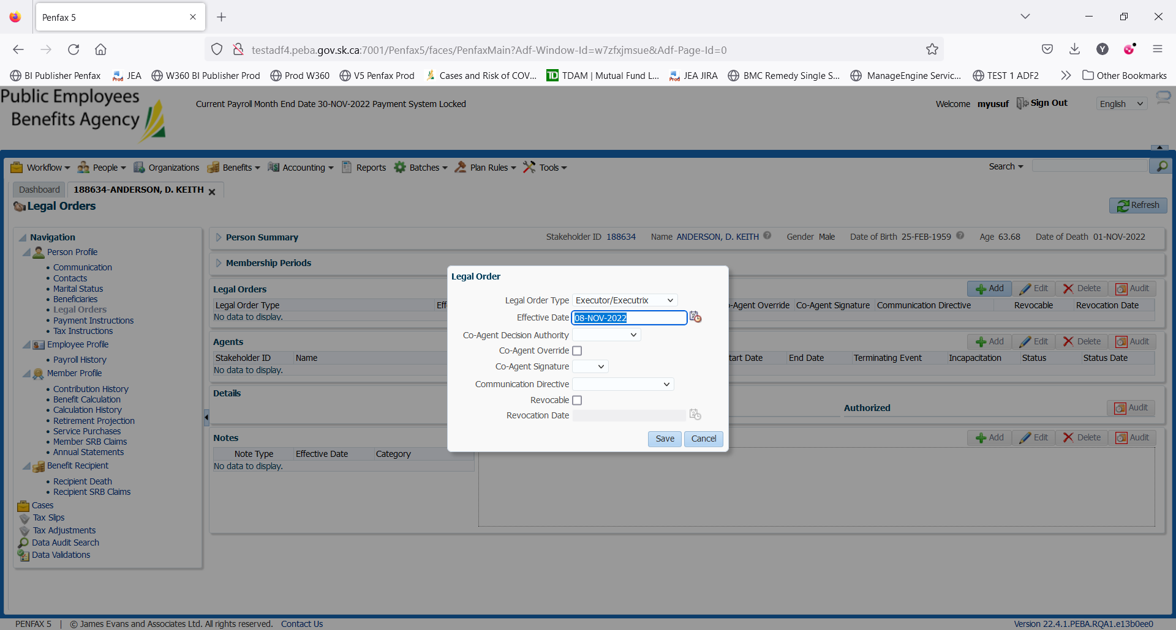

Click on Save

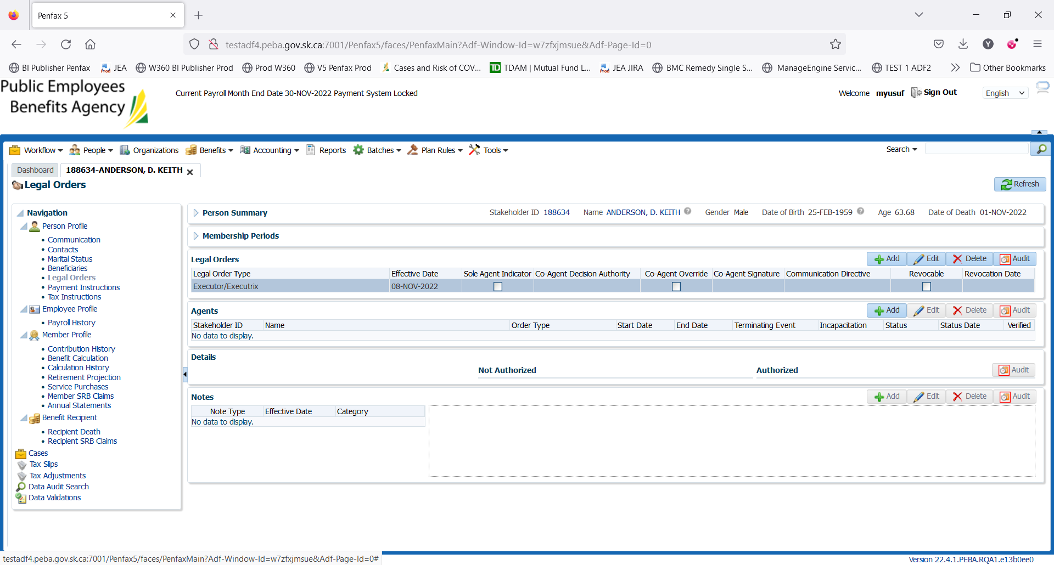

Click on Agents

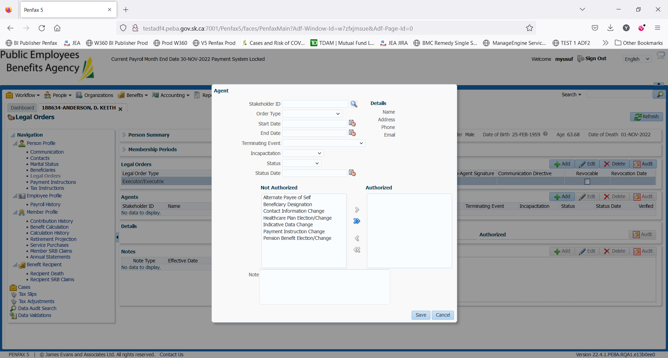

For Stakeholder: you can setup/add a new user or use an existing member

Using the existing member as an executor

